*Use the information in Chapter 9 (p.177-179) to complete the reading guide.*

**Concept 9.5 Fermentation and anaerobic respiration enable cells to produce ATP without oxygen**

1. **Explain** the difference between the processes of anaerobic respiration and fermentation.
2. **Discuss** alcoholic fermentation including the function of the production of ethanol, as well as an example of an organism that carries out this process.

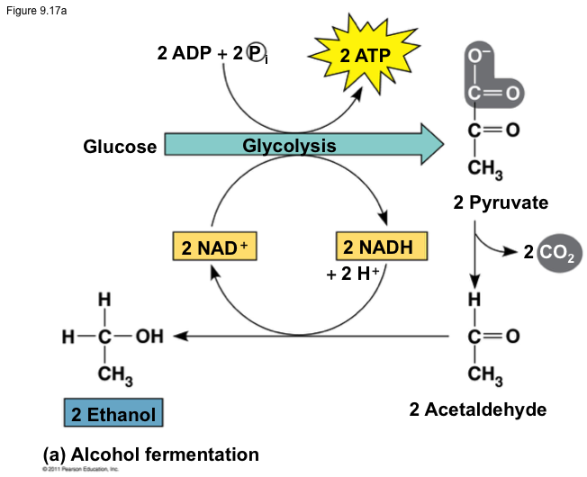

1. **Discuss** lactic acid fermentation including the function of the production of ethanol, as well as an example of an organism that carries out this process.

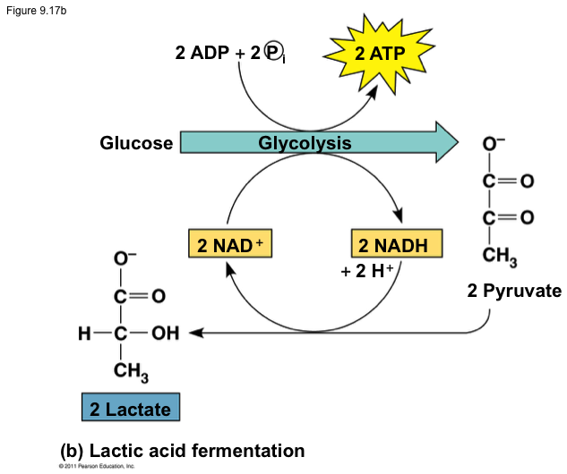

1. Discuss the difference between an obligate and facultative anaerobe.
2. What is the evolutionary significance of glycolysis?

**Concept 9.6 Glycolysis and the citric acid cycle connect to many other metabolic pathways**

1. Is glucose the only energy molecule that can fuel cellular respiration? Explain and give a couple of examples of alternative fuel.
2. **Discuss** how and why phosphofructokinase is a key regulatory enzyme in the process of cellular respiration.

